KAMPALA JUNIOR ACADEMY

HOLIDAY WORK SET TWO TERM I 2020
LITERACY II
PRIMARY TWO
Time allowed: 1 hour 30 minutes

My name is _________________________________________________
My school is ________________________________________________

1. ________________ is a place where we go to learn.
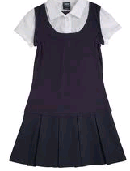
(home, school, market)
2. A dog is to puppy as duck is to _________________.

3. Tick √ the school symbols only.
(a) toilets (b) badge (c) books
(d) uniform

4. Give one type of family.
________________________________________________________
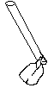
5. Complete the sentence correctly.
a. We use this tool for ___________ in the garden.

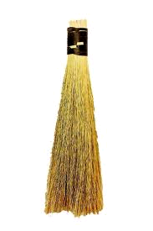
b. I can use this _____________ to sweep my classroom.

c. This is a school symbol. It is called a _________

d. This is a road ______________. It warns drivers about humps ahead.

6. Read and write True or False
a. A headteacher heads a school. _______________
b. Elephants are domestic animals. ______________
c. Plants give us food. ______________
d. A doctor treats patients. _______________

7. Read and complete correctly
a. I am a black rectangle. I am found in your class. Teachers use chalk to write on me. What am I?
___________________________________________________
b. I am a school symbol. I show the location of your school. What am I?
____________________________________________________
c. I live in a stable. You use me to carry things from one place to another. What am I?
____________________________________________________
8. Fill in the missing words.
Grand parents

Father

9. Read and match correctly
Home is a way of living.
Sanitation is a place where people or animals live.
Food is the general cleanliness of a place.
Culture is something good to eat or drink.

10. Draw these things found at school.
chalk | desk | book

11. Underline the odd number of the list.
- uniform  grass  badge  anthem | - chick  lamb  cow  puppy | - bursar  pilot  teacher  secretary

12. Write out the building materials we get from factories.
(a) timber ________________
(b) nails ________________
(c) grass ________________
(d) iron sheets
(e) clay
(f) cement
13. Match people to their work at home.
Mother helps parents with home chores.

Father cooks food

Children heads a family

14. Write Yes/No
(a) Do people eat food to die? ______________
(b) Is a watering can used in the garden? ___________
(c) Does a cook teach pupils in class? ____________

15. Circle places where we find wild animals.
Bush, home, forest, house, lake

16. Name these things created by God.
(a) (b) (c)

_____________ ______________ ____________
17. Moslems pray ___________ times a day. (two, one, five)
18. _______________ was the mother of Mohammed.
(Amina, Khadija)
19. An _______________ leads prayers in a mosque.
(Imam, pastor)

20. Read and answer questions.
God created water. We find water on earth. There is water in the sky. The water in the sky falls down on earth. This is called rain. We can get water from rivers, lakes and ponds.
Questions
- Who created water?
______________________________________________________
- Where do we find water?
_____________________________________________________
- Where does rain come from?
_____________________________________________________
- What do we get from rivers, lakes and ponds?
______________________________________________________

Good Luck

